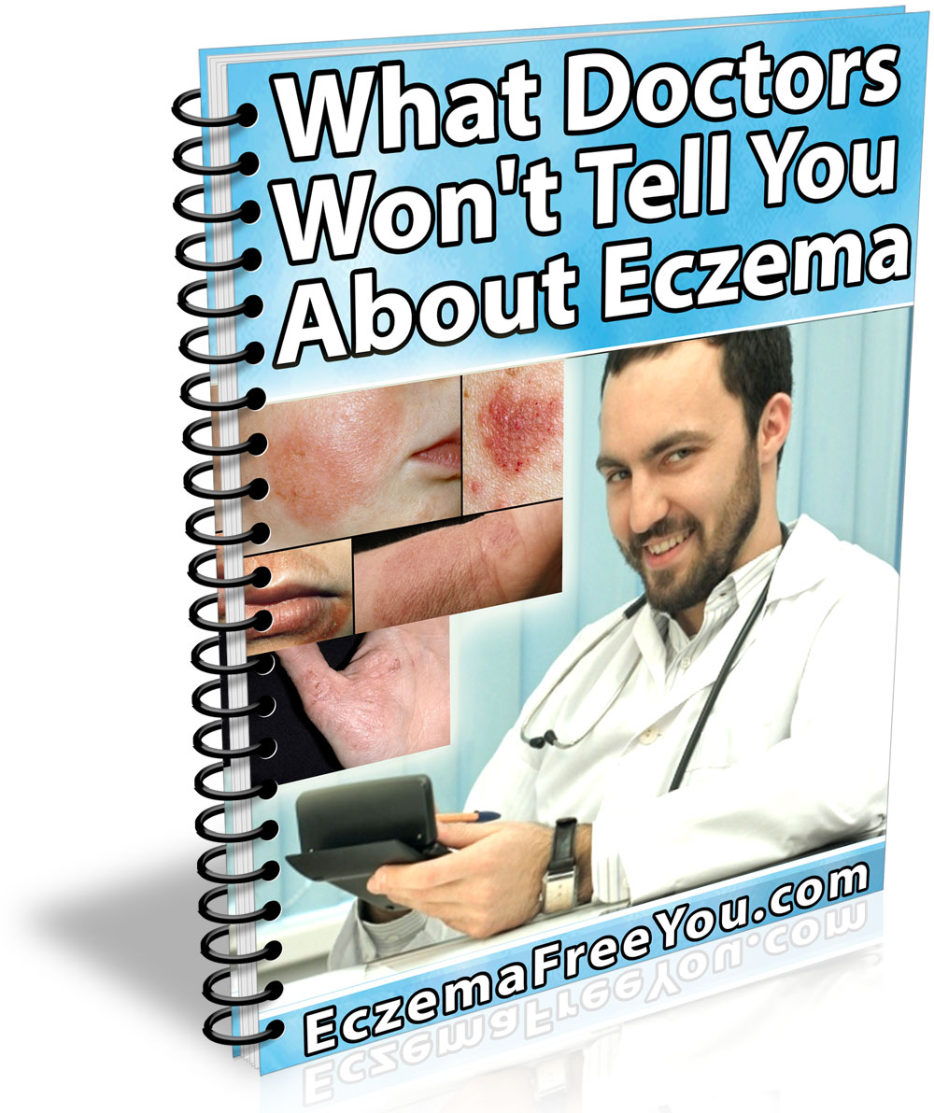
Copyright ©2018 by EczemaFreeYou.com
You are being granted Giveaway Rights to distribute this eBook for FREE as long as it’s not altered in any way.

We hope you enjoy reading this eBook. If you want to learn more on how to treat Eczema by using an easy to follow 100% natural system click on the link below:

www.EczemaFreeYou.com

What Doctors Won't Tell You
About Eczema

Second Edition

Table of Contents

Seeing Past EcZema Myths To Uncover the Truth 1
Myth: Eczema is a single condition or disease 2
Myth: Eczema is just a skin issue 3
Myth: eczema is one person’s problem 3
Myth: Eczema is contagious 5
Myth: The scars from eczema are permanent 5
Myth: Stress can directly start eczema 6
Myth: If you suffer from eczema, your skin can’t look normal 6
Myth: People with eczema should not try to swim 7
Myth: you must not give a child who has eczema a bath 8
Myth: Those who suffer from eczema do so because they do not bathe regularly 10
Myth: heavy use of moisturizer can negate the need for any other treatment 10
Myth: Dropping gluten from your diet can cure eczema 11
Myth: Eczema subsides naturally 12

Seeing Past EcZema Myths To Uncover the Truth

Eczema is quite common – and yet, while recent studies have shown that one in ten adults suffers from this condition, there are still quite a few misconceptions regarding eczema.
This because doctors are forced by the system to offer quick fixes - hence why short term solutions such as eczema creams are so popular.
The system doctors are trained to operate in is driven by the pharmaceutical industry. This multi-billion industry spends huge amounts of money to research and produce new medications. Thanks to today’s technology and the way news is freely shared, it’s an open secret and quiet obvious that the pharmaceutical industry is in the business of making money and not to make the world a better place free from diseases.
And that is why short-term medications, which need to be bought over and over again, are better than something which can be bought once to remedy a particular condition – at least in the industry’s eyes.
Just think about it, if you own a pharmaceutical company and spend millions of dollars to research a remedy for Eczema, would you rather produce a product which needs to be bought over and over again (therefore will bring you repeated sales) or one which can be bought only once? Often a company would lose money if it were to produce something which works too well.
There’s also the fact that natural remedies cannot be patented by pharmaceutical companies. As an example, if a company was to discover an all-natural Eczema remedy by consuming a mix of tomatoes and onions (as silly as it may sound) this said remedy is discarded because the company researching it cannot patent and commercialize it for profit.
This book will clear up a lot of those incorrect notions and tell you what you need to know to help treat this condition.

Myth: Eczema is a single condition or disease

Fact: Like the common cold, eczema is a term that is applied to a host of different skin issues; all of which cause irritated, reddened or itchy skin. There are a number of conditions which fall under the term “eczema”, and while the symptoms of these conditions might be similar, they are not the same condition.

For example, there is atopic dermatitis.
Atopic dermatitis is a chronic hereditary condition. It is a form of eczema that is most commonly found in children. Nine out of ten cases of atopic dermatitis will start showing symptoms before a child is five years old. Children with this condition usually have the symptoms disappear as they grow up.

In adults, the most common form of eczema is contact dermatitis.
Contact dermatitis is usually caused by various substances that can irritate the skin. These substances include detergents, harsh chemicals, fabric softeners and much more. The skin forms a protective barrier that protects the deeper and more sensitive layers of the skin, and any substances that can erode this barrier can cause contact eczema.

Myth: Eczema is just a skin issue

Fact: Eczema is very much more than just a skin issue and it can deeply affect the lives and personalities of people suffering from this condition. Studies on the subject have shown that people who have eczema are significantly more prone to drinking or smoking, and exercise less than those who do not have the condition.
This is because eczema can have a considerable emotional impact on those who suffer from it.

Those who suffer from eczema can have self-esteem issues. This is exacerbated by the fact that eczema can often begin in childhood, causing people to be affected by it through that crucial developmental period.

If eczema has been affecting your lifestyle choices, you should reach out for help.

Myth: eczema is one person’s problem

Fact: That is not true at all, as an entire family can be affected if one or more members have eczema.

The fact that eczema can be are genetic also means that the condition can frequently afflict several members of a family.

Besides this, if a person has eczema, it can affect their relationships with their spouse or children, as well as with other family members.
Taking strong medications for eczema can affect a person’s mood, and impact relationships with others.

We hope you enjoy reading this eBook. If you want to learn more on how to treat Eczema by using an easy to follow 100% natural system click on the link below:
www.EczemaFreeYou.com

Myth: Eczema is contagious

Fact: There is a tendency to assume that every skin condition can be easily transmitted.

Studies have found that eczema is not contagious.
However, if there is an infection present, such as staph, that infection could be contagious. Those who suffer from eczema can easily get infections because their skin barrier tends to be eroded.
If you are a person who suffers from eczema and notice a change in your skin condition that looks like an infection, you need to communicate with a health specialist.

Myth: The scars from eczema are permanent

Fact: In general, the scars from eczema are not permanent. While eczema is an unpleasant condition and can become quite uncomfortable, any scars that it leaves tend to fade over time.
You need to be careful when undergoing conventional medical treatments, as they can cause the skin to become discolored, grow thin, or develop stretch marks.
If you are taking conventional medical treatments for eczema, you need to communicate with your health specialist if you notice any side effects.

Myth: Stress can directly start eczema

Fact: Stress cannot directly cause eczema. However, it has been known to make the condition worse. This is because your body produces cortisol while under stress. Cortisol affects how well the skin retains moisture, and so can directly cause dry skin.
If your skin is already inflamed due to eczema, this will make the condition worse.
Two things that you can do to reduce both stress and the production of cortisol within your body are to get enough sleep and regular exercise.

Myth: If you suffer from eczema, your skin can’t look normal

Fact: While there are a wide range of conditions that come under the term “eczema”, many of them can be treated effectively, and a person’s skin can look normal. Atopic dermatitis is the hardest eczema condition to manage, but it can be made to go into remission.
With eczema, it is essential to start treatment the moment it is noticed; before the itching causes a person to rub or scratch their skin.
These responses will make the skin turn hard, or become thick, and this, in turn, makes the eczema harder to treat.

Myth: People with eczema should not try to swim

Fact: The chlorine in the water in swimming pools sometimes exacerbates cases of eczema, but this is relatively rare. There are also quite a few people with eczema who find that the chlorine actually helps suppress their symptoms.
If you find that your skin is irritated due to the chlorine in the water, apply moisturizer before swimming. Having a shower afterward can also help prevent any issues. Apply more moisturizer as soon as you get out of the shower.

Choose the right time for a swim
Another tactic that can help an eczema sufferer is to talk to the pool authorities and have them let you know when they add chlorine to the water. As chlorine tends to reduce in concentration as time passes, you can time your visit for when the levels are at a minimum.
Even if your eczema happens to be sensitive to chlorine, studies have shown that this sensitivity will reduce over time the more you go swimming, until you are not sensitive to chlorine at all.

We hope you enjoy reading this eBook. If you want to learn more on how to treat Eczema by using an easy to follow 100% natural system click on the link below:
www.EczemaFreeYou.com

Myth: you must not bath a child with eczema

Fact: The frequency with which you bathe a child who has eczema is not as crucial as how you go about it. It is critical to ensure that you bathe the child with warm water.

While the water should be warm, it must not be hot
You must also use a lot of moisturizer after the bath. Do not use bubble baths and only use the mildest of baby soaps. The fewer irritants the better. You must also not keep the child in the water for too long.
Using a moisturizer after the bath should ensure that the skin remains hydrated. As a general rule of thumb, avoid bath products that have artificial scents and fragrances.

Myth: Those who suffer from eczema do so because they do not bathe regularly

Fact: The last three myths illustrate the common belief among many people that eczema is somehow related to bathing habits or personal hygiene. In reality, doctors believe that eczema is caused by a variety of factors, which can include environmental irritants, immune responses, and the effect of one’s genes.

Any of these things can cause eczema, none of which are connected with a person’s hygiene.
Indeed, since people who have eczema suffer from dry skin, it has been found that they tend to bathe more regularly than people who do not have the condition.

Myth: heavy use of moisturizer can negate the need for any other treatment

Fact: While it is vital to regularly bathe if you have eczema and to moisturize after bathing, as well as at other times during the day, this is only a method of controlling the symptoms and not a full-scale treatment for eczema.

Used by itself, a moisturizer can only help reduce the symptoms of very mild eczema. If you suffer from more severe kinds of eczema, these will not be treatable solely with moisturizers. Advanced eczema leads to inflammation, and this inflammation needs to be controlled separately.

Myth: Dropping gluten from your diet can cure eczema

Fact: This cannot happen unless you have a medically proven sensitivity to gluten. Alternatively, this means that gluten does not aggravate eczema conditions.
Studies have found that even people who were sensitive to gluten did not see any reduction in their eczema after staying off gluten for at least eight months.

Myth: Eczema subsides naturally

Fact: In reality, rapid treatment is essential to negate the harshest symptoms of eczema. If left untreated, the scratching associated with eczema can cause severe inflammation, and infection, or, at the very least, severe scarring. The scratching and rubbing also cause additional irritation to the skin, which can aggravate the symptoms of eczema.
Many natural treatments can considerably help and even completely negate the effects of eczema, but they must be used quickly, before inflammation or infection sets in.
It is not that eczema can’t be treated once it is in the advanced stages, because of course, it can. However, managing the condition promptly can prevent a world of discomfort and stress.
By learning to differentiate between eczema myths and reality, you have already taken the first, initial step towards treating your eczema.

We hope you enjoy reading this eBook. If you want to learn more on how to treat Eczema by using an easy to follow 100% natural system click on the link below:
www.EczemaFreeYou.com

